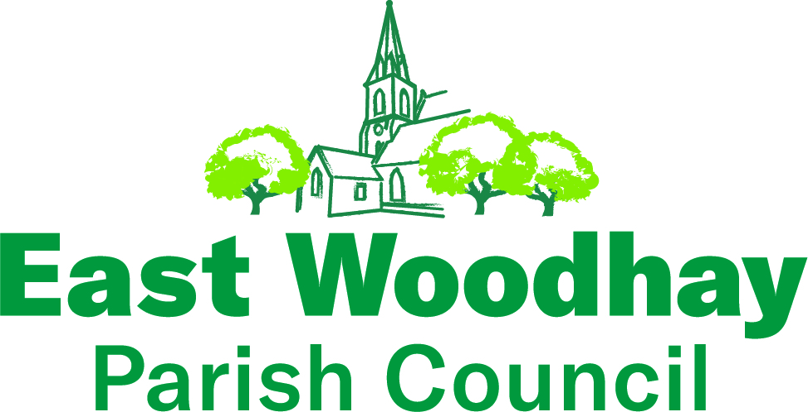

One of the lovely aspects of being in a rural area is the number of trees. However, as we know from the storms before Christmas there is a danger that branches or potentially a whole tree can fall.

Consequently, the Parish Council is taking a proactive approach and earlier in 2024 undertook a condition survey of all the trees on its land, which includes Woolton Hill recreation and playground, Heath End recreation ground, Woolton Hill parish field and Meadowbrook open area near Tile Barn Row. This survey was undertaken by an independent, approved arboricultural surveyor and will be done every 3 to 5 years.

The survey identified 9 points of work on the parish council land, including several ash trees with dieback and others where growth or its general condition was causing a potential hazard. The parish council looked at the potential risk of each and it was decided that, rather than addressing the trees over a longer period, it was best to deal with all of the actions quickly. All of the work was completed during December.
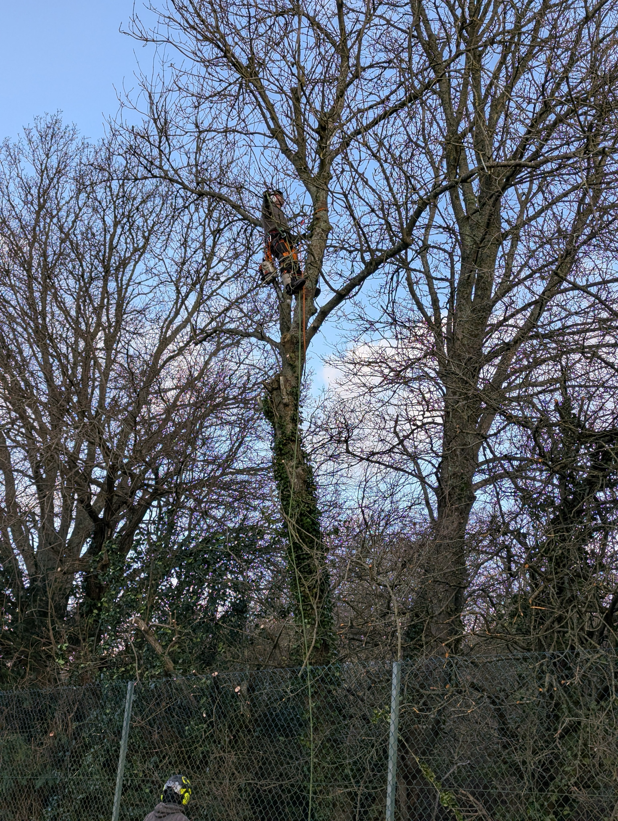
The cost of maintenance of parish council assets continues to be a significant part of the whole budget and for tree maintenance the amount this year has been just over £5,000, which is around 12% of our annual income from residents.

